Digital Readiness & Barriers to Purchase
Recommended Study Name: Digital Readiness to buy [PRODUCT]
Objectives: Assess whether shoppers are ready to purchase specific products online and explore current barriers to online purchasing

Email Invite
Subject: Would you ever buy [PRODUCT] online?

Hi [%FirstName%],

We’re curious about what types of products you purchase online compared to a store, and whether you would ever consider buying all your [PRODUCT] online?

Click here to get started. Or, copy and paste this link into your browser: [%ActivityLink%]

[CONSIDER INSERTING TAKE-AWAYS FROM A PREVIOUS ACTIVITY TO FEED BACK TO MEMBERS AND DRIVE ENGAGEMENT]

Enjoy!
[COMMUNITY NAME]

Questionnaire

[Q1] Online Purchase Categories
Question Type: Multi Choice
Who sees this question? All members

Do you currently buy any of these products online on a regular basis (like every couple of months or so)?

[SELECT A MAXIMUM OF 10-15 PRODUCT CATEGORIES THAT ARE RELEVANT TO YOU. USE THE SAMPLE LIST BELOW OR ADD YOUR OWN.]

[RANDOMIZE]
Beverages
Books
Cleaning products
Clothing
Cosmetics
Computers
Groceries
Phones
Snacks
Water
I have not purchased any of these products online [ANCHOR][EXCLUSIVE]

PRO-TIP: Use this question as a possible shareback to the community.

[PROGRAM No Online Purchase – Introduction and No Purchase of Product Questions ON THE SAME PAGE]

[Q2] No Online Purchase - Introduction
Question Type: Text & Image
Who sees this question? All members that have not purchased products from Online Purchase Categories

Why have you not purchased the following products online in the past few months?

[SHOW ONLY A MAXIMUM OF TWO OR THREE PRODUCTS FOR MEMBERS TO TELL YOU ABOUT – POTENTIALLY THE SAME TWO OR THREE THAT ARE MOST CLOSELY RELATED TO YOUR PRODUCT]

PRO-TIP: How do I only show a few  of the answer choices, you ask?  - Create a page and add a text & image box. This will house the main question text [Why have you not purchase the following products online in the past few months?]  - Insert a group, and then pull a survey logic widget onto the page and place a long answer question inside. Specify the survey logic to show the long answer question if the corresponding product category IS NOT selected OR “I have not purchased any…” IS selected in the previous question.  - Duplicate the survey logic and long answer question for each product category.  - In the Group options, select the option to display the objects in a random order and to display two or three. | 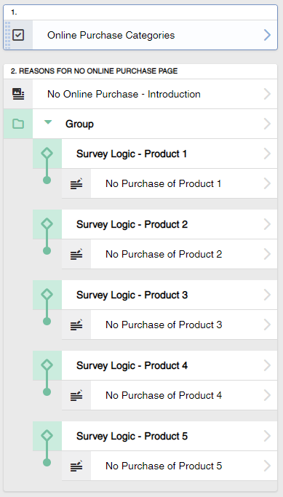

[Q2A] No Online Purchase – Product 1
Question Type: Long Answer
Who sees this question? All members that have not purchased Product 1 OR have not purchased any of the products from Q1

[PRODUCT 1]

[REPEAT Q2A AS NEEDED]

[Q3] Readiness
Question Type: Single Choice
Who sees this question? All members

Would you consider purchasing [ITEM] online?

Absolutely yes
Hmmm… not sure
Definitely not

[Q4] Online Purchase Interest
Question Type: Allocation Slider
Who sees this question? All members

Thinking of your next 11 purchases of [ITEM], how many will you buy online compared to in a store?

[ROWS][RANDOMIZE]
Online
In a store

[Q5] Future Online Purchase
Question Type: Single Choice
Who sees this question? All members

Thinking ahead to a year from now, how do you think your purchasing will change between in-store and online?

Much more online
Somewhat more online
About the same as now
Somewhat more in-store
Much more in-store

[Q6] Online Barriers
Question Type: Multi Choice
Who sees this question? All members

Which of these prevent you from purchasing [ITEM] online?

[SELECT UP TO 10 STATEMENTS RELEVANT TO YOU OR CHOOSE FROM THE SAMPLE LIST BELOW]

[RANDOMIZE]
Concerned about payment security
Don’t have the right selection
Don’t like buying [ITEM] online
Find better prices in the store
I dislike the delivery options
I like to see and touch before I buy
I need it right away
Not available for purchase online
Not convenient
Process takes too long
The shipping costs are too expensive
Website navigation is too complicated
Another reason (please tell us): [ANCHOR][OPEN END]

[IF “Definitely not” IS SELECTED AT Q3, ASK Q7]

[Q7] Reason for No Online Consideration
Question Type: Long Answer
Who sees this question? All members who would never purchase [ITEM] online at Q3

Are there any other reasons why you wouldn’t buy [ITEM] online?

[Q8] Online Change
Question Type: Text + Allocation Slider
Who sees this question? All members

Imagine a world where…

[INSERT YOUR IDEAS FOR ENCOURAGING YOUR CUSTOMERS TO BUY ONLINE – BELOW ARE A FEW EXAMPLES]

[ITEM] would be delivered to your door within 24 hours
You would receive special discounts when you purchase online
There were no shipping costs for returning products
Access to special products and product bundles only available online

Now, how many of your next 11 purchases of [CATEGORY] would happen online compared to in a store?

[ROWS][RANDOMIZE]
Online
In a store

PRO-TIP: Compare current purchasing habits [Q4 and Q5] to this question to see how your customers’ online purchasing habits might change in the future.

[Q9] Trends
Question Type: Single Choice Grid
Who sees this question? All members

What do you think of these other ideas? Let us know by choosing the statement that best expresses your opinion.

[INSERT LIST OF UP TO 7 IDEAS OR CHOOSE FROM THE SAMPLE LIST BELOW]

[COLUMNS]
I already do this
Someday I might do this
Not for me, but it might be good for others
I don’t like this idea

[ROWS]
Daily Deal: Buy products or services via email that are discounted for a period of 24-36 hours.
Showrooming: Look at products in a store and then buy it online, sometimes for a lower price.
Store Shipping: Avoid shipping charges of online purchase by picking up the items in the store.
Instant Mobile Payment: Instead of standing at the check-out counter, use your phone to purchase the product and walk out the door.
Name Your Price: Purchase via websites that allow you to make an offer that the company can accept or reject.
“Essentials” subscription: Automatic delivery of basic household items that need on a regular basis.

[THIS QUESTION IS OPTIONAL TO INCLUDE]

[Q10] Previous Experience
Question Type: Open End
Who sees this question? All members

We’re very interested in learning about your experiences when shopping for [CATEGORY]. To learn more about this, we would like for you to tell us about your last shopping experience for [CATEGORY]. Think back to that shopping experience and write down everything you can remember about the experience starting with entering the area of the store where [CATEGORY] is sold.

Please tell us what you were thinking and feeling. Tell us about the shopping process you followed that lead to your decision to buy the brand you bought.
Survey Complete
Question Type: End Survey
Who sees this question? All members

That’s it! Thanks so much for your time to let us know your thoughts about shopping for [PRODUCT] online. The insights that you and your fellow community members have shared will help us to figure out our digital strategy moving forward.

We really appreciate the feedback and look forward to hearing from you again soon.

Thanks again!
[COMMUNITY NAME]

Color Coding

Pro-tips
Input needed from you [customer]
Sparq pipe
Sparq settings
Sparq logic

